You can translate this transcript to any language.

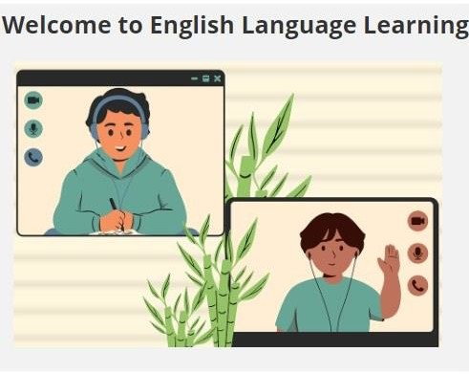

Student Orientation

Welcome
- – Let’s get started!

Welcome to the Student Orientation for the English Language Learning program.

In this tutorial, you will:

- learn about the English Language Learning (ELL) program

  - become familiar with the ELL learning environments

    - get ready to begin your ELL program

To navigate to a specific area of this orientation, select the icon in the bottom, right-hand corner of this webpage. This opens a Table of Contents. Select the Table of Contents and select any part of the orientation to jump directly to it.

Program Overview

The English Language Learning Program

Our ELL program is designed to increase your listening, speaking, reading, and writing in English. The program is aligned to the Common European Framework scale of English proficiency (CEFR).

You will be placed into the ELL course that matches your ELL goal level.
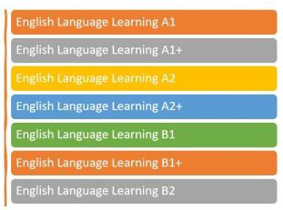

- - There are seven ELL courses.

Learning Environments

Learning Environments

The program takes place during an 18-week semester.

You will use three learning environments to learn English:

  - Study App

  - My Virtual Campus

    - Classroom
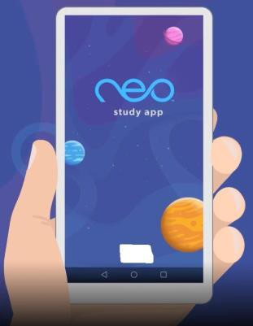

- - neo™ Study App

- - My Virtual Campus ELL Course

- - You may be in a classroom or at home.

Getting Started

Log In

Go to https://myvsoe.maestrosis.com.

Fill in your User Name and Password.

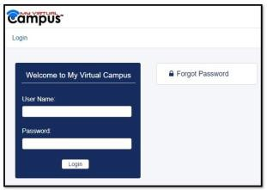

Read Announcements
- - This is the My Virtual Campus login screen.

Read the announcements every day. There may be messages from your teacher or the system administrator.
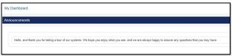

Check Email
- - Find the announcements box in My Virtual Campus.

Be sure to read and reply to your email messages each day.

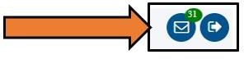

Find Your Course
- - Check your email every day.

Locate your course title.

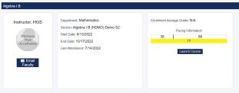

- - There are three sections here.

Send a message to your teacher.

You can send your teacher a message from this link.
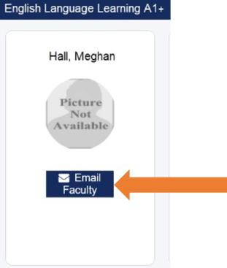

Course Information
- - Email your teacher with questions.

Here you see the name of your course, your start and end dates, and the last day you were in class.

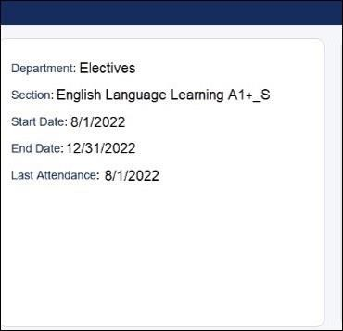

Pacing Information
- - Remember to go into your course every day.

This is where you see information about your pacing and performance.

  - On the top, the first number shows how many days have gone by since the course began. The second number shows how many days are left in the course.

    - On the bottom, the number shows how many assignments you have left to complete.

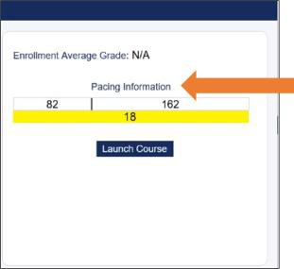

Launch Your Course
- - Pay close attention to your Pacing Information.

Launch your ELL course.
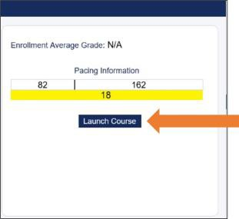

Open Your Course
- - Let's get started!

Select the course from the new window.

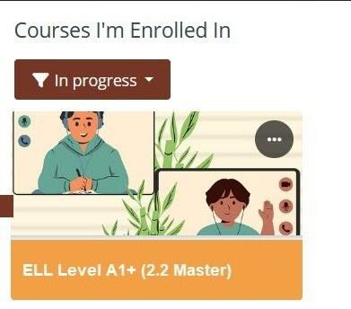

- - Your ELL course tile will look like this.

Working in the Program

Working in the Program

Welcome to your ELL course.

Select Getting Started to begin.
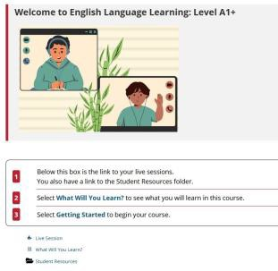

- - You will see several links on this page.
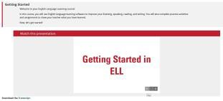

Course Syllabus
- - This page will help you get off to a great start.

The Course Syllabus is found in the Student Resources folder.
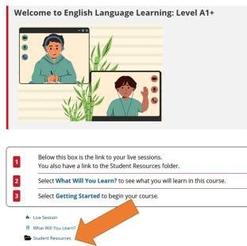

- - The Student Resources folder has several helpful links.

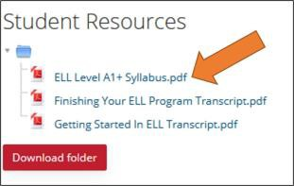

- - Open the Syllabus to learn more.
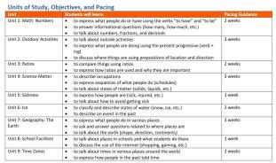

- - Scroll to the end to see the units of study, what you will learn, and pacing information.

Choose Your Unit

Start your lesson each day in your ELL course.

Choose your unit title.

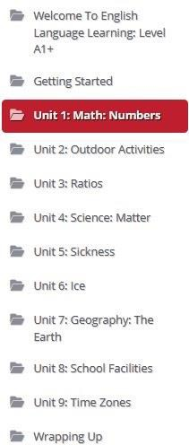

- - Use the syllabus pacing chart to keep track of the unit you are working on.

Time to Study: Your Points and Study Now

Go to Time to Study.

See how many points you've earned.

Select the Study Now button to begin using the Study App.

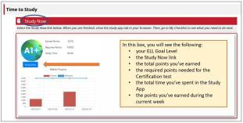

30 Minutes a Day
- - The information updates in real time.

Spend 30 minutes a day in the Study App.
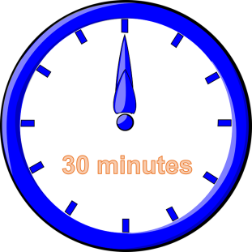

4,500 Points Each Week
- - Keep track of how much time you spend in the app.

Earn points by completing activities in the Study App.

You need to earn 4,500 points each week.

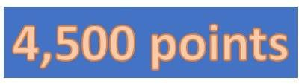

- - Work hard to earn 4,500 points every week.

Study App

The Study App

Your ELL Goal Level is at the top.

See your points next to the rocket.
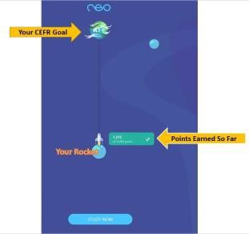

Mastery Tests
- - Use the STUDY NOW button to start in the app.

You will take mastery tests along the way.

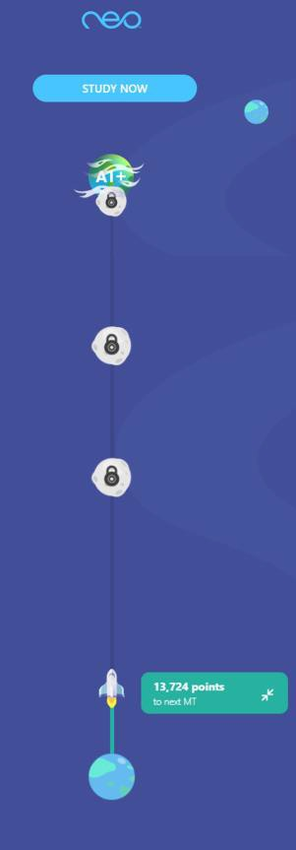

The Learning Path
- - Watch your rocket head closer to the mastery test locks.

Follow the learning path in the Study App.
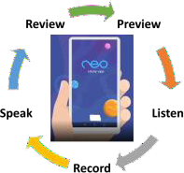

- - The app will guide you through the lessons and these activities.

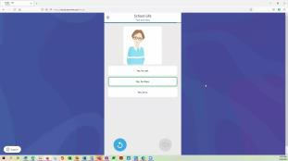
Select play on the video to see a demo of what you will experience in the Study App.
Select the image above to launch the Student Demo Video

After 30 Minutes

After 30 minutes, close the Study App.

Then, log out of the Study App.

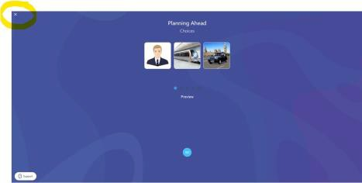

- - That's enough for now.
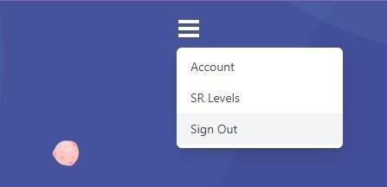

- - Time to sign out of the Study App.

Return to Your ELL Course

Return to Your ELL Course

Return to My Virtual Campus and your ELL course.

Select My Checklist
- - Welcome back to your course.

The My Checklist link shows you what you need to do in the unit.
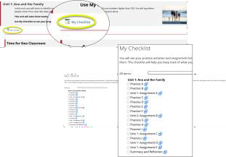

Practice and Assignments
- - My Checklist updates in real time.

There are practice activities and assignments each week.

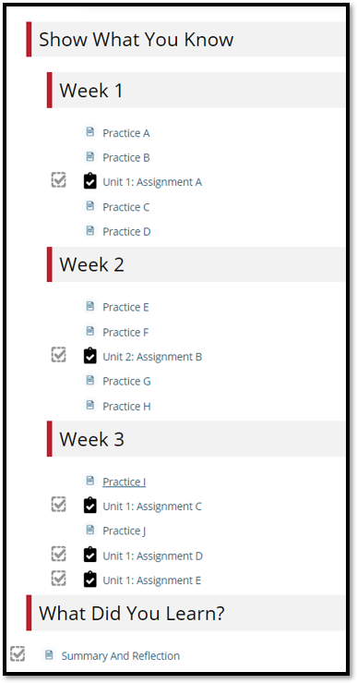

- - This unit takes 3 weeks. There are practice activities and assignments each week.

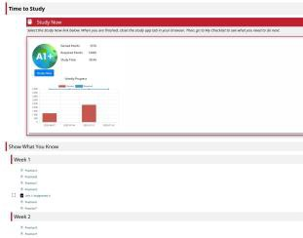

- - The list is found under the Time to Study Box on the unit home page.

Reading and Translation Tool

You will find the SpeechStream Reading and Translation tool in many of your courses. Use this cloud- based language and literacy toolbar for the following tasks:

  - Click or hover the hand to read selected text aloud

  - Play, pause, or stop reading all the text on the page aloud

- Translate a single word or multiple words into dozens of languages

  - Use a text dictionary to define selected words

  - Use a picture dictionary to define selected words

    - Personalize the settings for the tool

To open and close the toolbar, select the arrow on the far right-hand side of the bar.

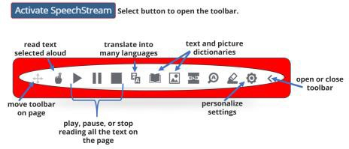

- - Use the SpeechStream tool to help you read text on the page.

18 Weeks to Certification

18 Weeks to Mastery

When you earn 4,500 points each week, and you complete the practice activities and assignments in your ELL course, you will be ready for the Certification Test.

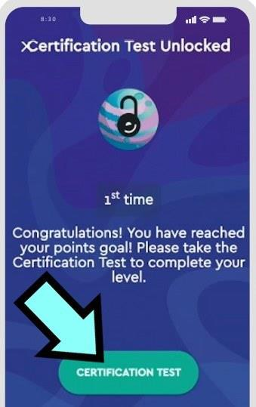

- - You can take the Mastery Tests and the Certification Test three times. There are review lessons, too.

Certificate
It's Certificate Time!

At the end of the semester, you will take your certificate test. When you pass the test, you earn your certificate for your ELL goal level.

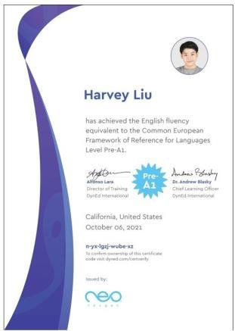

- - Let's put your name on the certificate.

Have a great semester!

